**Ref. No. MES IMCC / 198/ 2024 – 25 Date:19/12/2024**

**CERTIFICATE**

This is to certify that the Project entitled **“RandomlyRight** “is completed by **“Vaibhavi Kulkarni**” of M.C.A. Semester I for the Academic Year 2024-25 at MES’ Institute of Management & Career Courses (IMCC), Pune - 411038.

To the best of our knowledge, this is an original study done by the said student and important sources used by him/her have been duly acknowledged in this report.

The report is submitted as a part of course ITP11 Mini Project for the Academic Year 2024-25 as per the rules and guidelines prescribed by the institute.

  

Ms. Kalpana Dhende Ms. Manasi Shirurkar Dr. Ravikant Zirmite

Project Coordinator Program Coordinator Head, Dept. Of MCA

**Ref. No. MES IMCC / 198/ 2024 – 25 Date:19/12/2024**

**CERTIFICATE**

This is to certify that the Project entitled **“RandomlyRight** “is completed by **“Krish Undre**” of M.C.A. Semester I for the Academic Year 2024-25 at MES’ Institute of Management & Career Courses (IMCC), Pune - 411038.

To the best of our knowledge, this is an original study done by the said student and important sources used by him/her have been duly acknowledged in this report.

The report is submitted as a part of course ITP11 Mini Project for the Academic Year 2024-25 as per the rules and guidelines prescribed by the institute.

  

Ms. Kalpana Dhende Ms. Manasi Shirurkar Dr. Ravikant Zirmite

Project Coordinator Program Coordinator Head, Dept. Of MCA

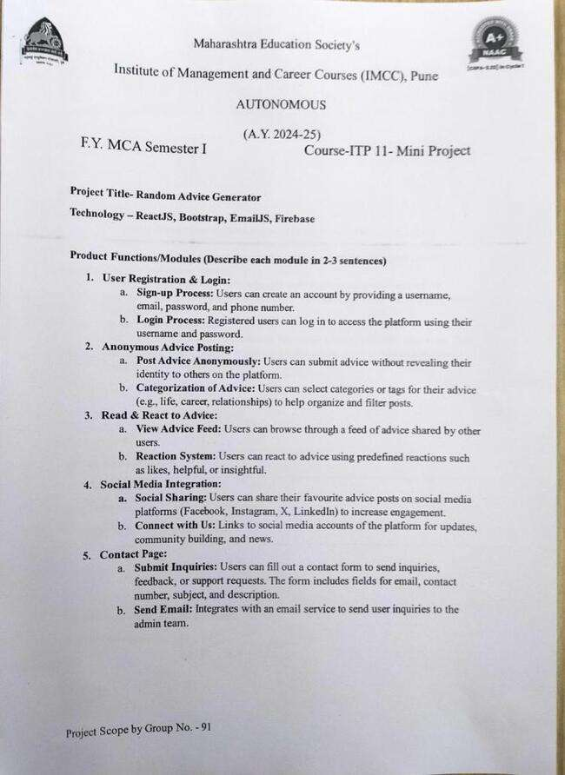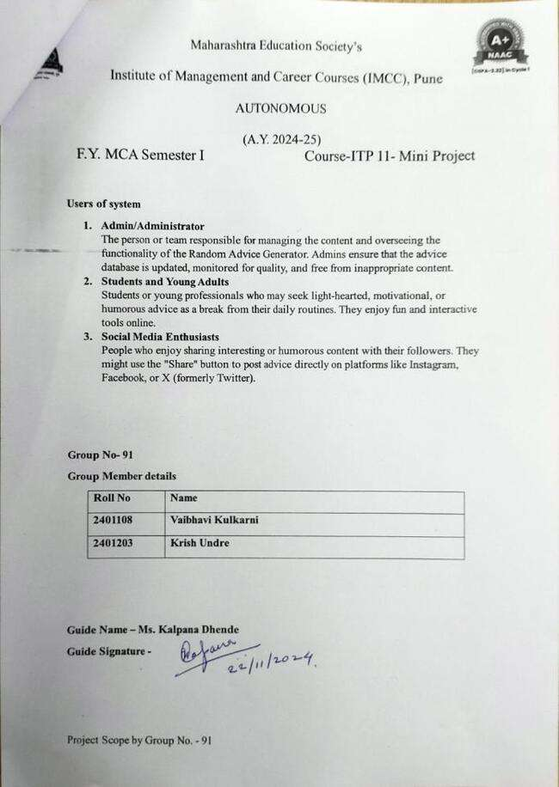

|  |
| --- |
| **RandomlyRight** |

**Developed by:**

Krish Undre

Vaibhavi Kulkarni

**Hosting URL:**

<https://randomlyright.vercel.app/>

**Index**

|  |  |  |
| --- | --- | --- |
| **Sr. No.** | **Content** | |
| 1 | Introduction of Project | |
|  | 1.1 | Introduction |
|  | 1.2 | Problem Statement and Objective |
| 2 | Scope & Functionalities of Project | |
|  | 2.1 | Scope |
|  | 2.2 | Functionality |
| 3 | Use Case Diagram | |
| 4 | Input Design, Output Design (GUI) | |
| 5 | Database Design | |
| 6 | Validations | |
| 7 | Conclusion | |

**Chapter-1**

**Introduction of RandomlyRight**

**1.1 Introduction of the Project:**

RandomlyRight is a web-based application designed to provide users with a platform to share, view, and engage with anonymous advice on various topics. The main goal of this project is to create a space where users can seek and offer advice without the fear of judgement, fostering a supportive community. Users can create accounts to participate, post advice anonymously, react to advice, and share posts on social media.

Curing boredom is its main purpose, offering users an engaging outlet for their thoughts and creativity. With the rise of digital platforms, sharing thoughts, ideas, and experiences has become an integral part of human interaction. This project takes inspiration from the need for anonymity in such interactions, allowing users to express their opinions and advice freely. Whether it's personal growth, career guidance, or life tips, the platform provides a simple and intuitive way for users to contribute their wisdom or benefit from others' experiences.

**Key Features:**

* **User Authentication:** Users can create an account, log in, and securely access the platform. All advice shared is anonymous to other users, ensuring privacy and security.
* **Post and Share Advice:** Users can submit their advice anonymously, which gets displayed on the platform. Other users can react to the advice and share it on social media platforms.
* **Interactive Interface:** The platform offers a user-friendly interface with social media integration, allowing advice posts to gain visibility and spark conversations.

This documentation provides a comprehensive overview of the RandomlyRight project, covering all stages. The project leverages modern web technologies and follows best practices to ensure a smooth user experience and robust performance.

**1.2 Problem Statement and Objective of the Project:**

**Problem Statement:**

In today's fast-paced and digitally connected world, people often seek advice or support on personal, professional, and emotional matters. However, fear of judgement or exposure can prevent individuals from asking for help or sharing their thoughts openly. Most existing platforms that allow users to seek advice are either too public or lack anonymity, leading to hesitation in sharing or seeking guidance. This can result in missed opportunities for individuals to get valuable advice, perspectives, and support from a community.

Additionally, there is a lack of a dedicated platform that encourages anonymous interactions for advice-sharing while also providing the ability to engage with, react to, and share advice in a safe and supportive environment. Addressing this gap can help foster more honest and open communication among individuals who might otherwise refrain from seeking or offering advice.

**Objective:**

The objective of RandomlyRight project is to create a user-friendly web application that allows individuals to share and seek anonymous advice on various topics without the fear of judgement or exposure.

**The platform will:**

* **Promote Anonymity:** Ensure that users can share advice or seek guidance without revealing their identity, creating a safe space for open communication.
* **Foster Engagement:** Provide features like reactions, comments, and social media sharing to encourage users to engage with and spread helpful advice.
* **Enable Account Creation:** Allow users to create secure accounts while ensuring that their interactions remain anonymous to other users.
* **Ensure Privacy:** Comply with data protection and privacy laws, especially in the Indian context, to safeguard user information and ensure a secure experience.
* **Enhance Usability:** Offer a simple, interactive, and aesthetically pleasing interface that caters to a youthful audience, making it easy for users to navigate and contribute to the platform.

This project aims to fill the existing gap by offering a safe, anonymous, and supportive environment where individuals can give and receive advice freely while ensuring data security and privacy compliance.

**Chapter-2**

**Scope and Functionalities**

**2.1 Scope of the Project:**

RandomlyRight aims to provide users with a simple yet engaging way to receive random advice that can be both fun and insightful. This project is designed with a focus on accessibility and ease of use, ensuring that users can interact with the website effortlessly, whether on a desktop or mobile device.

**Core Objectives:**

* **User-Friendly Interface:** The project will feature a clean, intuitive user interface, allowing users to easily generate advice with a single click.
* **Randomised Advice Generation:** The key functionality of the website is to provide users with random advice from a diverse database of phrases. Each interaction will present the user with unique advice.
* **Creative and Fun Experience:** The project was inspired by casual conversations, and the goal is to replicate that feeling of spontaneous fun. The advice provided can range from humorous to thought-provoking.
* **Future Enhancements:** The project is designed with scalability in mind, allowing for the future addition of features like categorised advice, user-submitted advice, and a daily advice feature.
* **Responsive Design:** The website will be fully responsive, ensuring a seamless experience across devices, including smartphones, tablets, and desktops.

By focusing on these objectives, RandomlyRight aims to be a playful yet practical tool, allowing users to explore bits of advice whenever they need inspiration or a quick laugh.

**2.2 Functionalities of the Project:**

RandomlyRight application offers a variety of functionalities aimed at creating an engaging and anonymous platform for users to share and seek advice.

These functionalities are divided into core and additional features:

**Core Functionalities:**

1. **User Registration & Login:**
   * Sign-up Process: Users can create an account by providing a username, email, password, and phone number.
   * Login Process: Registered users can log in to access the platform using their username and password.
   * Secure Authentication: The application ensures the protection of user credentials and provides secure access to the platform.
2. **Anonymous Advice Posting:**
   * Post Advice Anonymously: Users can submit advice without revealing their identity to others on the platform.
   * Categorization of Advice: Users can select categories or tags for their advice (e.g., life, career, relationships) to help organize and filter posts.
3. **Read & React to Advice:**
   * View Advice Feed: Users can browse through a feed of advice shared by other users.
   * Reaction System: Users can react to advice using predefined reactions such as likes, helpful, or insightful.
   * Advice Sharing: Users can share advice posts on social media platforms (Instagram, X, Facebook, etc.) directly from the app.
4. **Profile Management:**
   * Manage User Profile: Users can update their profile information, including their username and password.
   * View Posted Advice: Users can view a list of advice they've shared anonymously, but only within their private account dashboard.

**Additional Functionalities:**

1. **Social Media Integration:**
   1. Social Sharing: Users can share their favourite advice posts on social media platforms (Facebook, Instagram, X, LinkedIn) to increase engagement.
   2. Connect with Us: Links to social media accounts of the platform for updates, community building, and news.
2. **Contact Page:**
   1. Submit Inquiries: Users can fill out a contact form to send inquiries, feedback, or support requests. The form includes fields for email, contact number, subject, and description.
   2. Send Email: Integrates with an email service to send user inquiries to the admin team.
3. **Privacy and Terms:**
   1. View Privacy Policy: Provides users with a comprehensive privacy policy outlining data collection and protection practices.
   2. View Terms of Service: Users can read the terms of service that outline the conditions of using the platform.
4. **Error Handling:**
   1. Error Notifications: Users are notified in case of submission errors (e.g., invalid form data) or login failures.
   2. Success Messages: Displays confirmation messages upon successful actions (e.g., post submission, form submission).
5. **Mobile Responsiveness:**
   1. Responsive Design: The application is optimized for mobile, tablet, and desktop devices, ensuring a smooth user experience across different screen sizes.

These functionalities aim to provide an engaging and secure platform where users can freely share and receive advice while maintaining control over their data and interactions.

**Chapter-3**

**Use Case Diagram**

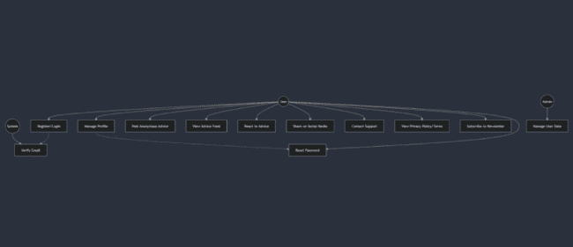

The use case diagram illustrates the main interactions between actors and system functionalities in RandomlyRight:

**Key Actors:**

- User: Main actor who interacts with most system features

- Admin: Manages user data and system

- System: Handles automated processes

**Main Use Cases:**

1. Authentication/Profile:

- Register/Login with email verification

- Profile management with password reset capability

- Newsletter subscription

2. Core Features:

- Post and view anonymous advice

- React to advice

- Share advice on social media

3. Support/Policy:

- Contact support system

- Access privacy policy and terms

- Admin management of user data

The dotted lines show dependencies, like email verification being required after registration and password reset being connected to profile management.

**Chapter-4**

**Input Design, Output Design (GUI)**

**Sign In Page**

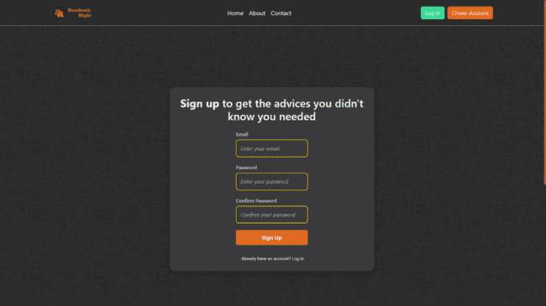

**Additional Details**

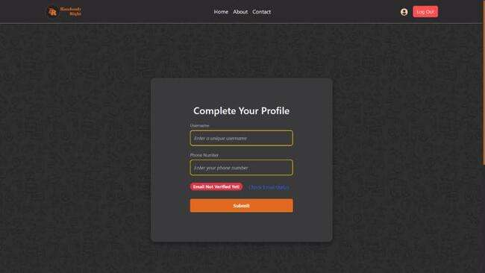

**Profile Completion**

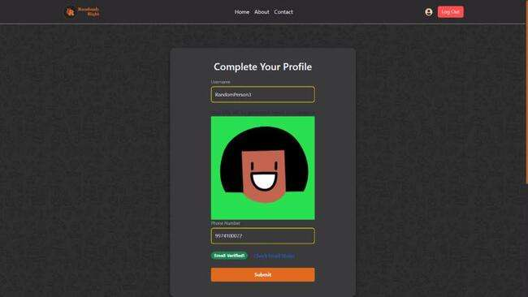

**Log In Page**

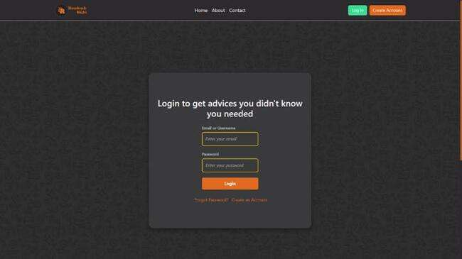

**Home Page**

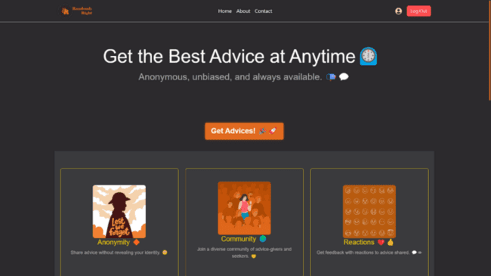

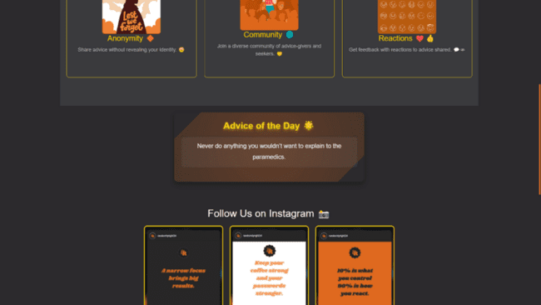

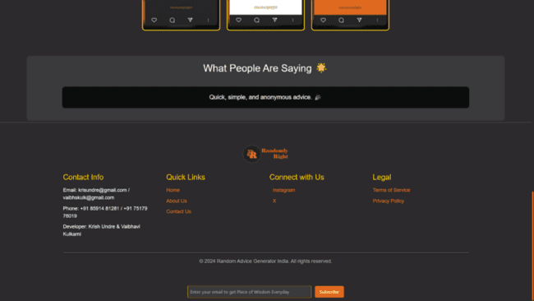

**Advices Page**

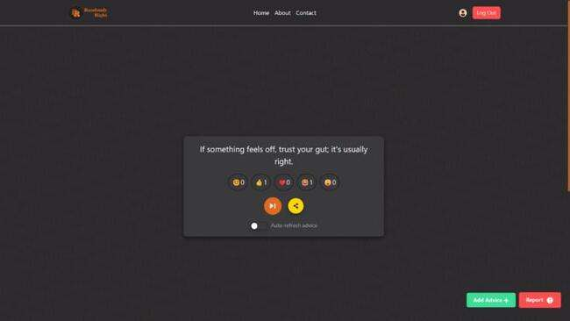

**Add Advice Page**

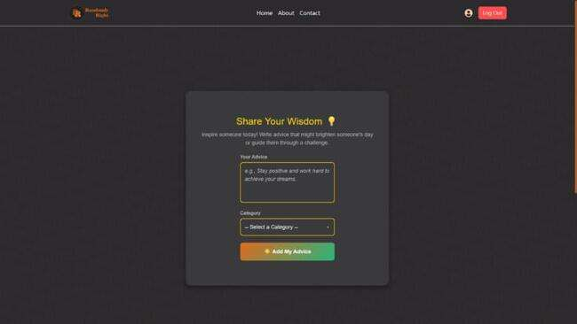

**Contact Us Page**

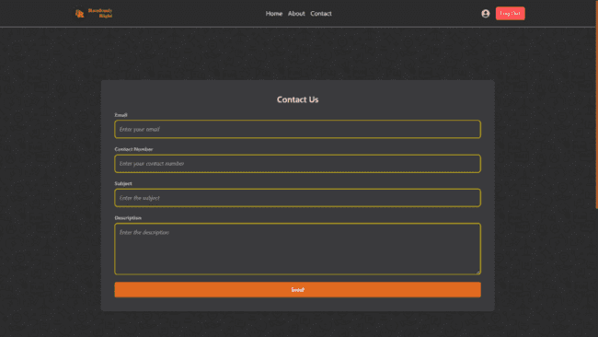

**Privacy Policy**

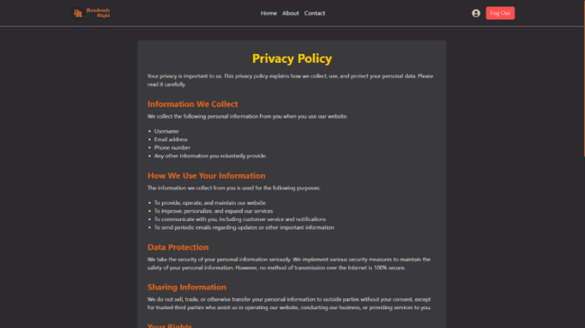

**Terms Of Services**

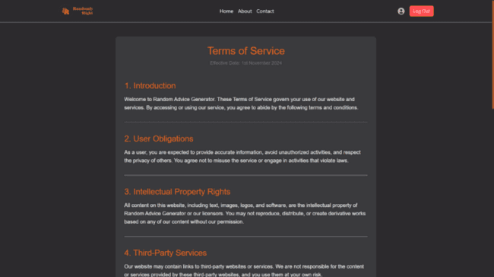

**About Us**

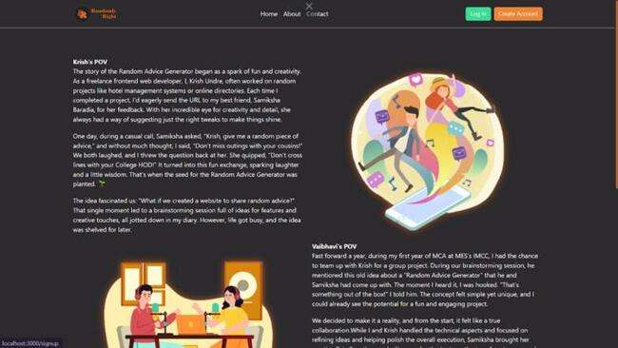

**Profile Page**

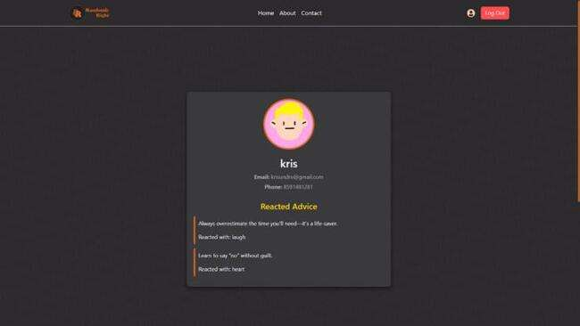

**Reset Password**

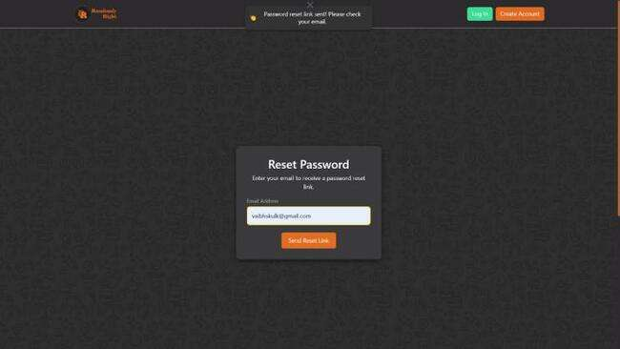

**Newsletter Subscription**

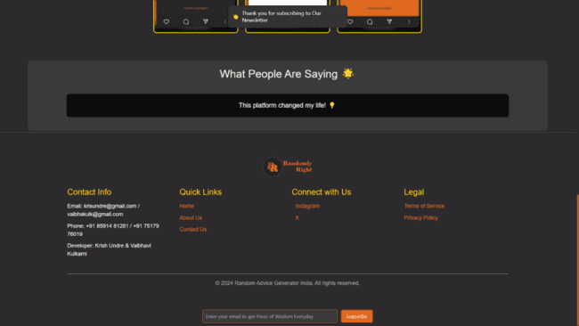

**Chapter-5**

**Database Design**

**Firebase Database for Users**

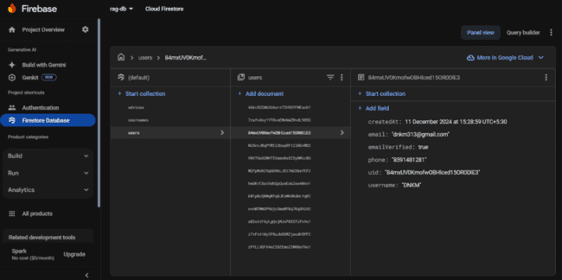

**Firebase Database for Usernames**

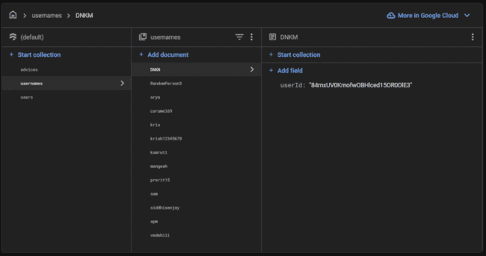

**Firebase Database for Advices**

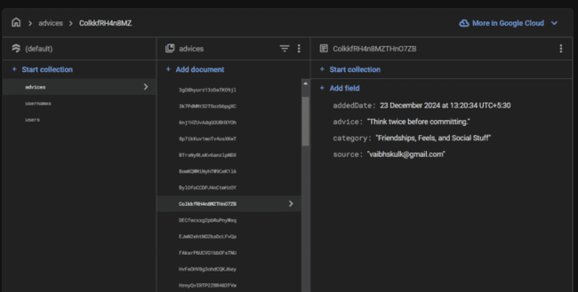

**Chapter-6**

**Validations**

**Email Validations**

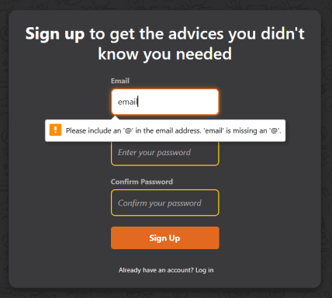

Occurrence: When users enter invalid email.

**Password Requirements**

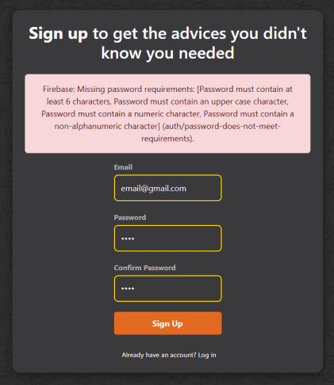

Occurrence: When users do not meet valid password requirements.

**Add Advice Validations**

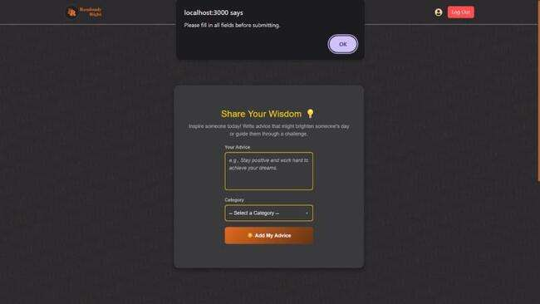

Occurrence: When users select ‘Add Advice’ without entering advice input.

**Email Verification**

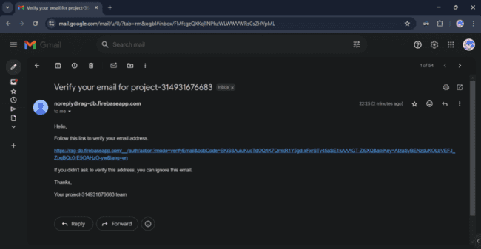

Occurrence: Verification mail after Signing in successfully.

**Conclusion**

RandomlyRight project is a dynamic and innovative platform that bridges the gap between individuals seeking or offering advice in a safe, anonymous, and engaging environment. By addressing the challenges of public exposure and judgment associated with traditional advice-sharing platforms, this application empowers users to connect, contribute, and engage freely without compromising their privacy.

With its user-friendly interface, robust functionality, and emphasis on anonymity, the platform is designed to foster meaningful interactions while providing a touch of spontaneity and fun. Core features such as anonymous advice posting, reactions, social media sharing, and personalized user dashboards make it a versatile and interactive tool for users across various demographics.

Additionally, the inclusion of responsive design and secure authentication mechanisms ensures accessibility and safety for users on all devices. The project’s vision for scalability opens doors for future enhancements, such as categorized advice and user-submitted features, further solidifying its role as a comprehensive advice-sharing platform.

In conclusion, RandomlyRight is more than just a digital tool; it is a solution-oriented platform that encourages openness, creativity, and supportive community-building in the fast-paced digital age. With its commitment to privacy, functionality, and user satisfaction, it has the potential to become a go-to platform for those seeking inspiration, guidance, or a simple moment of connection.

